# Report 2: System Analysis & Architectural Design Report

## System Overview

1.1. Purpose: This document specifies the requirements for the Train Booking Application, as reverse-engineered from the codebase.

1.2. Scope: The Train Booking Application is a desktop application designed to manage train bookings, including user authentication, train and route management, seat selection, and booking confirmation. It caters to both customers for booking and managers for system administration.

1.3. Intended Audience & User Roles: This document is for the engineering team. The identified user roles (Actors) are:

    - Customer: A user who can register, log in, search for trains, book tickets, and view their bookings.

    - Manager: A user with administrative privileges who can manage train schedules, routes, coach types, seat types, pricing rules, and stations.

1.4. Design and Implementation Constraints:

    - The system is built on .NET 8.0 (WPF).

    - It uses Entity Framework Core for data access.

    - It requires a SQL Server database.

    - The application utilizes a Model-View-ViewModel (MVVM) architectural pattern.

## UML Diagrams

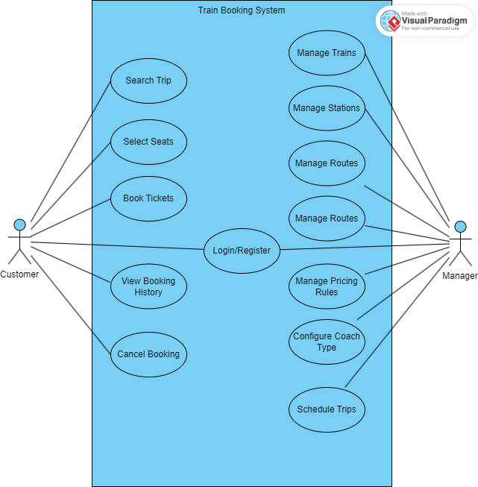

**Use Case Descriptions**

|  |  |  |
| --- | --- | --- |
| Use Case | Actor(s) | Description |
| Register Account | Customer | Allows a new customer to create an account within the system. |
| Login | Customer, Manager | Enables registered users (customers or managers) to gain access to the system. |
| Search Trains | Customer | Allows customers to search for available train trips based on specified criteria. |
| Select Seats | Customer | Enables customers to choose desired seats for a selected train trip. |
| Book Ticket | Customer | Facilitates the process of confirming seat selection and completing a train ticket booking. |
| View Bookings | Customer | Allows customers to view their past and upcoming train bookings. |
| Manage Trains | Manager | Enables managers to add, update, and delete train information in the system. |
| Manage Routes | Manager | Allows managers to define, modify, and remove train routes, including associated stations. |
| Manage Coach Types | Manager | Enables managers to define and manage different types of train coaches. |
| Manage Seat Types | Manager | Allows managers to define and manage various types of seats available on trains. |
| Manage Pricing Rules | Manager | Enables managers to create, update, and delete pricing rules for tickets. |
| Manage Stations | Manager | Allows managers to add, update, and delete train station information. |

**Sequence Diagrams:**

**Customer Books a Ticket:**

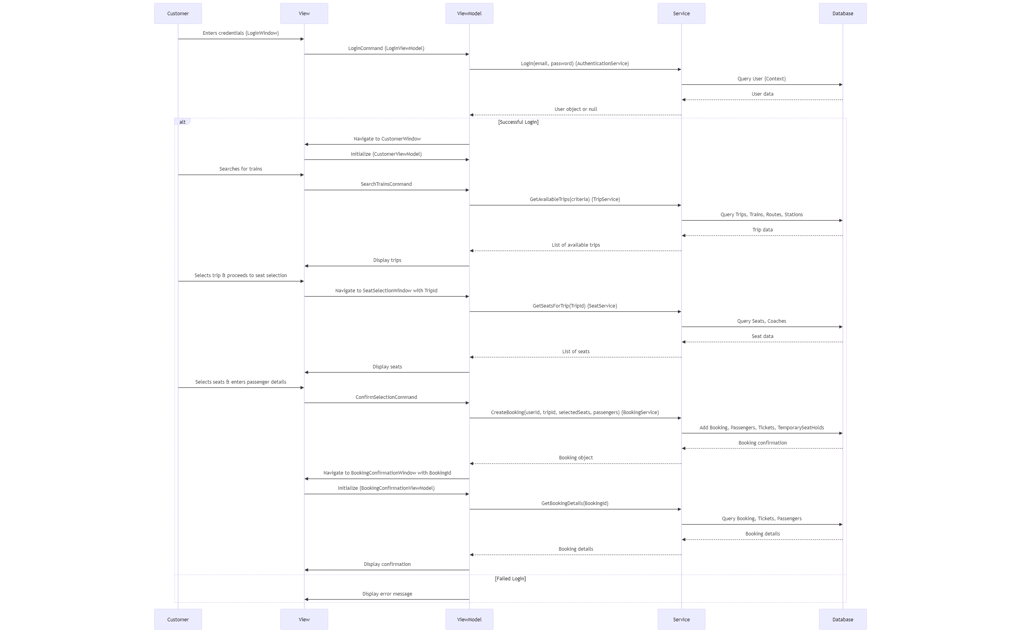

**2.3. Sequence Diagrams:**

**Manager Adds a New Route:**

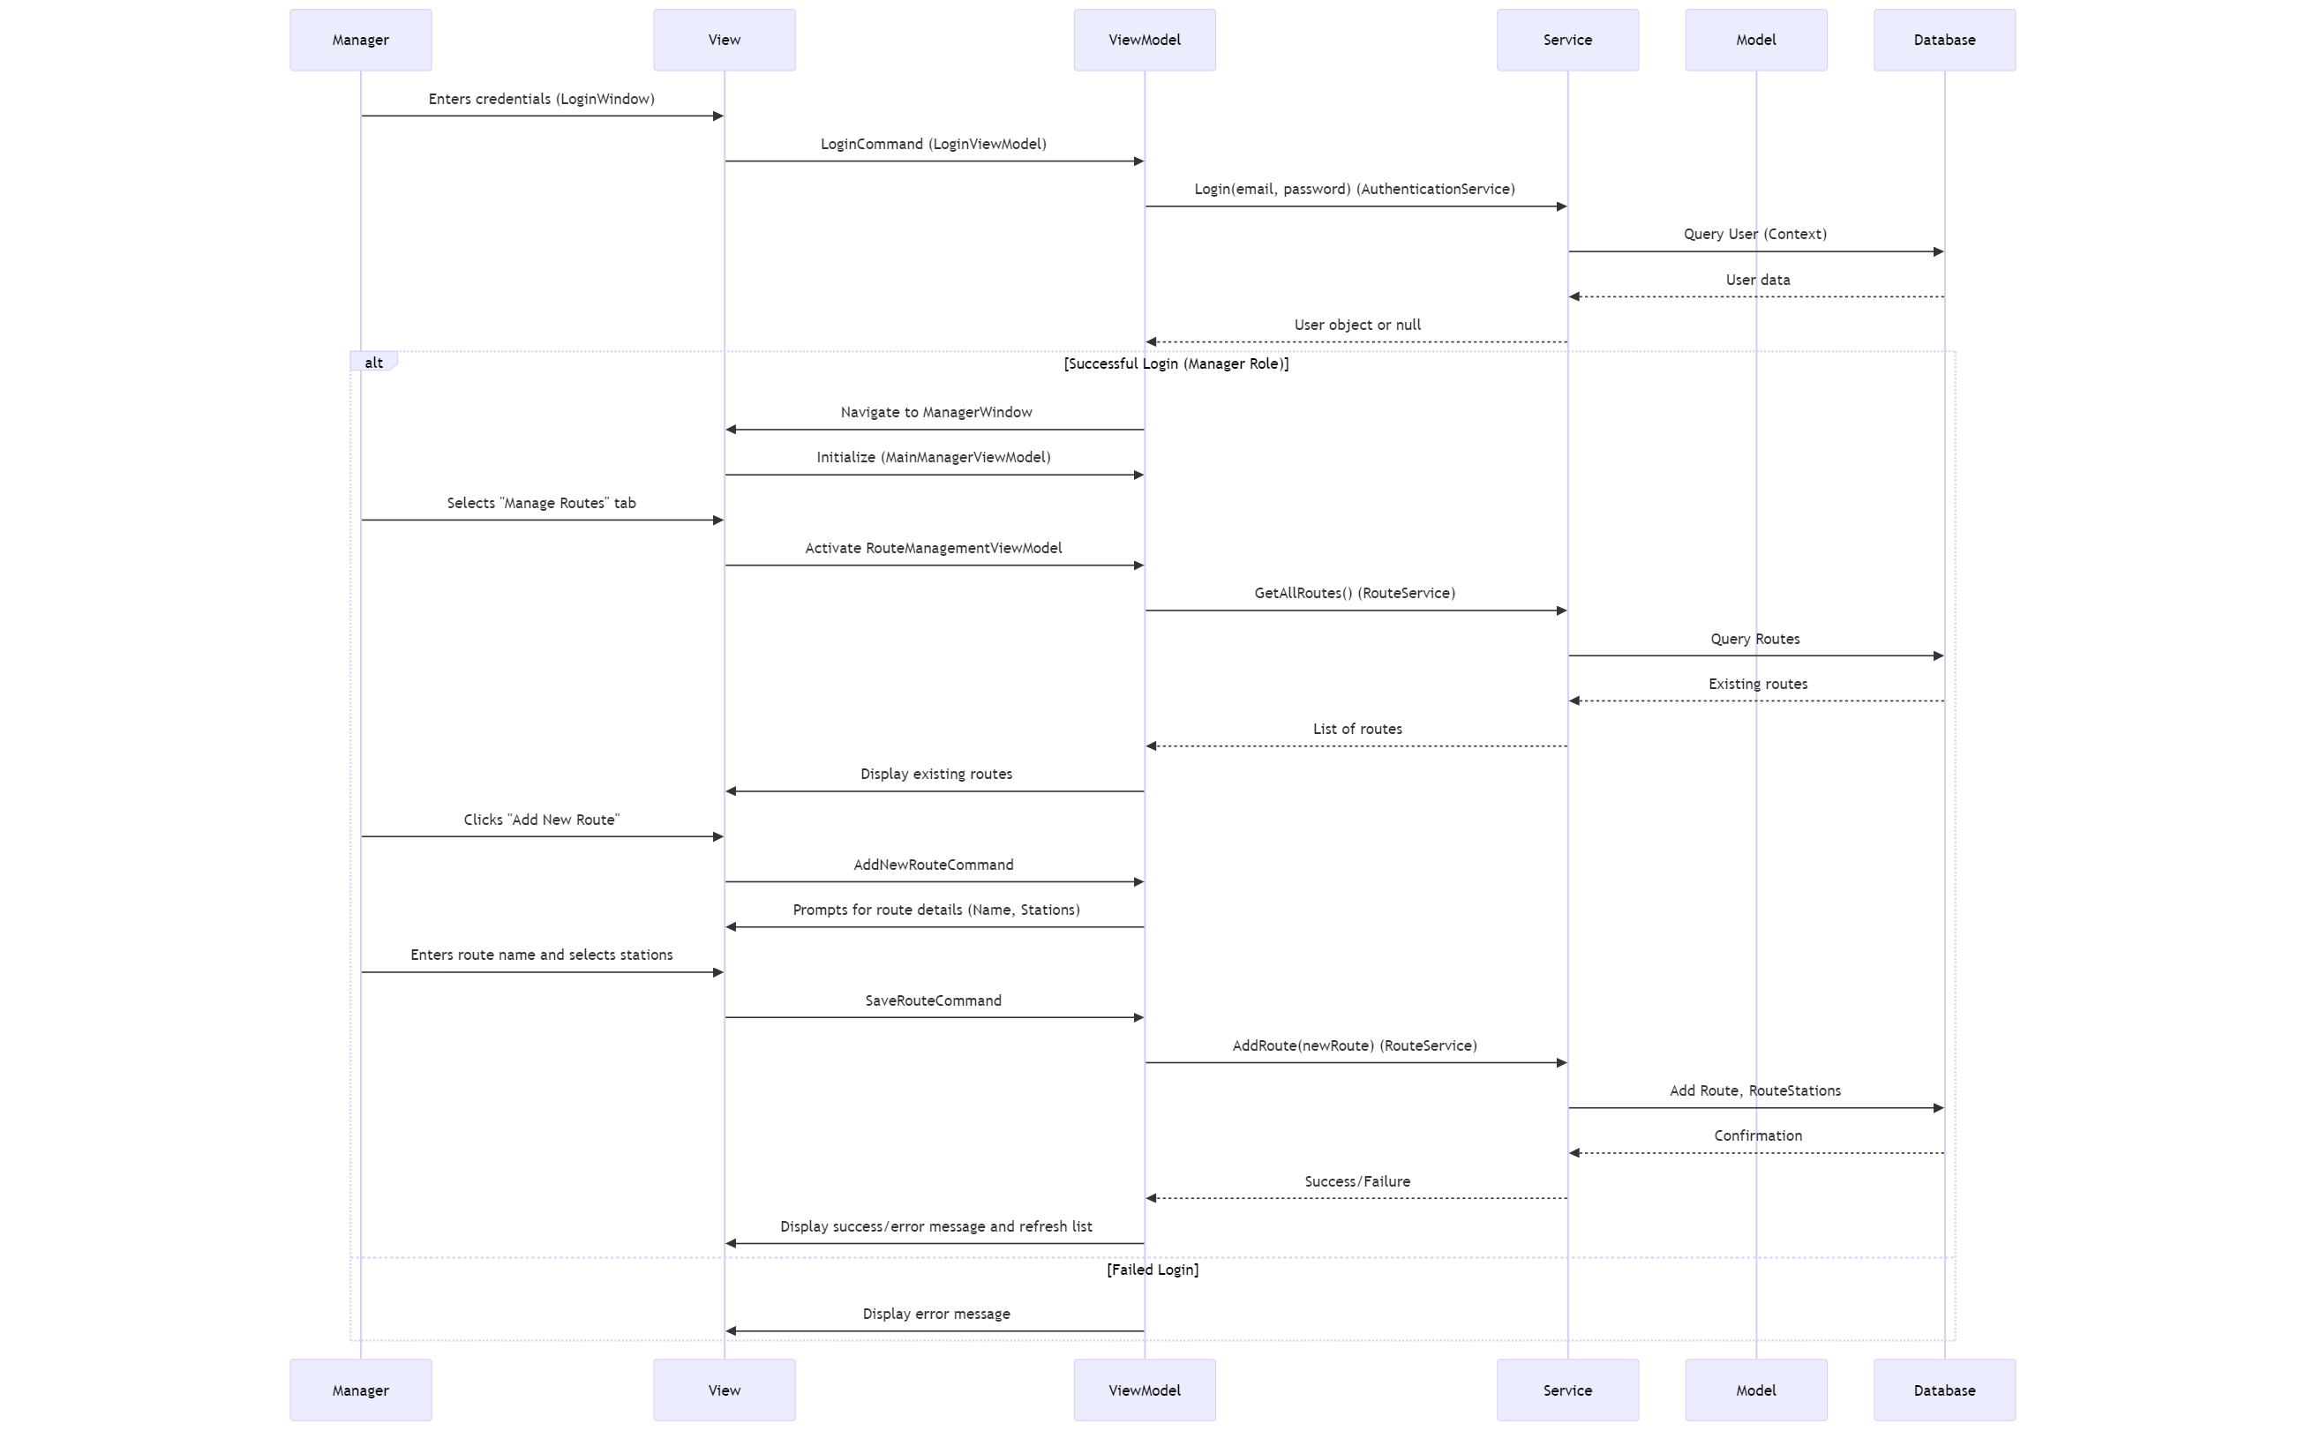

## Database Design

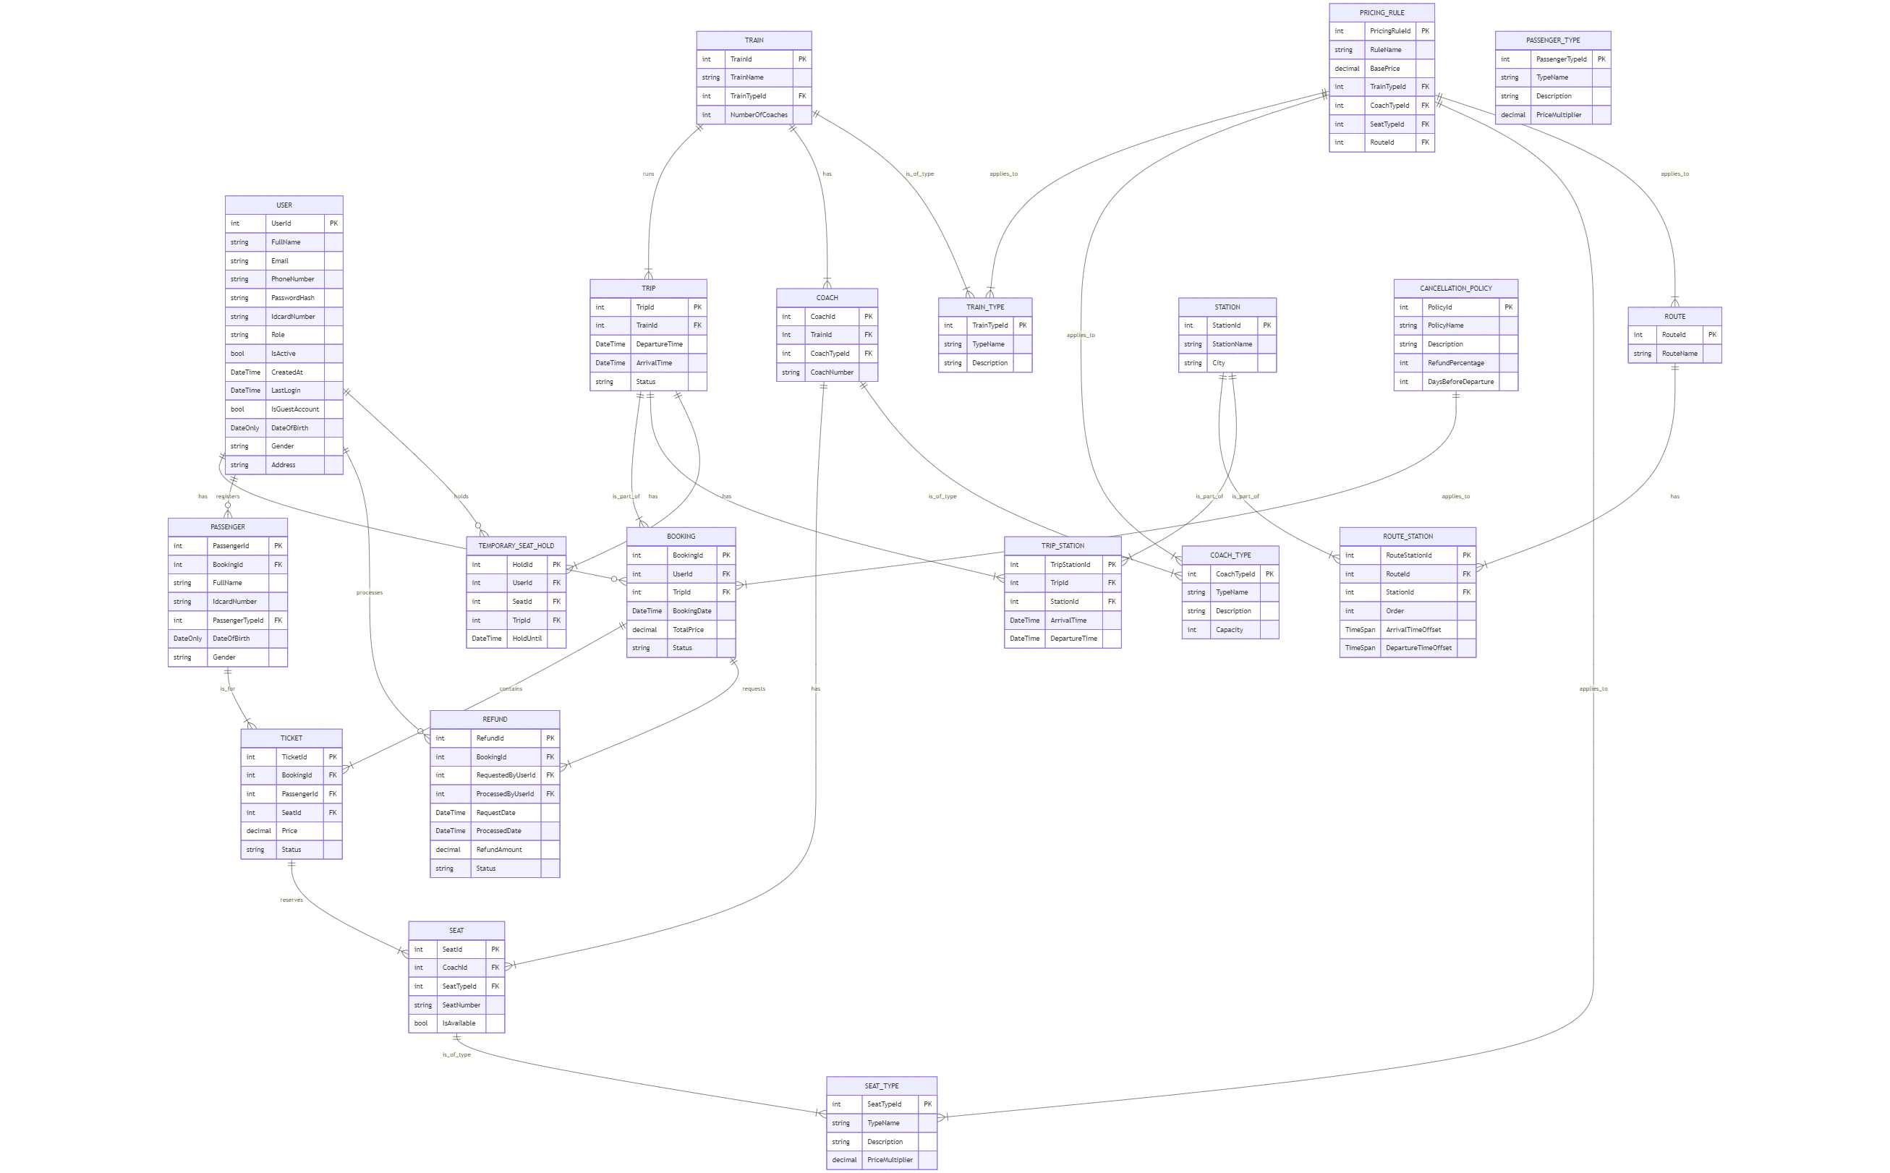

**Database Schema and Table Descriptions:**

**Table: Users**

|  |  |  |  |
| --- | --- | --- | --- |
| Column Name | Data Type | Constraints | Description |
| UserId | int | PK | Unique identifier for the user. |
| FullName | string | NOT NULL | Full name of the user. |
| Email | string | NOT NULL, UNIQUE | Email address of the user, used for login. |
| PhoneNumber | string | NOT NULL | Phone number of the user. |
| PasswordHash | string | NULLABLE | Hashed password of the user. |
| IdcardNumber | string | NULLABLE | ID card number of the user. |
| Role | string | NOT NULL | Role of the user (e.g., "Customer", "Manager"). |
| IsActive | bool | NOT NULL | Indicates if the user account is active. |
| CreatedAt | DateTime | NULLABLE | Timestamp when the user account was created. |
| LastLogin | DateTime | NULLABLE | Timestamp of the user's last login. |
| IsGuestAccount | bool | NOT NULL | Indicates if the user is a guest. |
| DateOfBirth | DateOnly | NULLABLE | Date of birth of the user. |
| Gender | string | NULLABLE | Gender of the user. |
| Address | string | NULLABLE | Address of the user. |

**Table: Bookings**

|  |  |  |  |
| --- | --- | --- | --- |
| Column Name | Data Type | Constraints | Description |
| BookingId | int | PK | Unique identifier for the booking. |
| UserId | int | FK (Users) | Foreign key to the Users table. |
| TripId | int | FK (Trips) | Foreign key to the Trips table. |
| BookingDate | DateTime | NOT NULL | Date and time when the booking was made. |
| TotalPrice | decimal | NOT NULL | Total price of the booking. |
| Status | string | NOT NULL | Current status of the booking (e.g., "Confirmed", "Pending", "Cancelled"). |

**Table: Trips**

|  |  |  |  |
| --- | --- | --- | --- |
| Column Name | Data Type | Constraints | Description |
| TripId | int | PK | Unique identifier for the trip. |
| TrainId | int | FK (Trains) | Foreign key to the Trains table. |
| DepartureTime | DateTime | NOT NULL | Scheduled departure time of the trip. |
| ArrivalTime | DateTime | NOT NULL | Scheduled arrival time of the trip. |
| Status | string | NOT NULL | Current status of the trip (e.g., "Scheduled", "Departed", "Arrived", "Cancelled"). |

**Table: Trains**

|  |  |  |  |
| --- | --- | --- | --- |
| Column Name | Data Type | Constraints | Description |
| TrainId | int | PK | Unique identifier for the train. |
| TrainName | string | NOT NULL | Name of the train. |
| TrainTypeId | int | FK (TrainTypes) | Foreign key to the TrainTypes table. |
| NumberOfCoaches | int | NOT NULL | Total number of coaches in the train. |

**Table: Coaches**

|  |  |  |  |
| --- | --- | --- | --- |
| Column Name | Data Type | Constraints | Description |
| CoachId | int | PK | Unique identifier for the coach. |
| TrainId | int | FK (Trains) | Foreign key to the Trains table. |
| CoachTypeId | int | FK (CoachTypes) | Foreign key to the CoachTypes table. |
| CoachNumber | string | NOT NULL | Unique number or identifier for the coach within a train. |

**Table: Seats**

|  |  |  |  |
| --- | --- | --- | --- |
| Column Name | Data Type | Constraints | Description |
| SeatId | int | PK | Unique identifier for the seat. |
| CoachId | int | FK (Coaches) | Foreign key to the Coaches table. |
| SeatTypeId | int | FK (SeatTypes) | Foreign key to the SeatTypes table. |
| SeatNumber | string | NOT NULL | Unique number or identifier for the seat within a coach. |
| IsAvailable | bool | NOT NULL | Indicates if the seat is currently available. |

**Table: Stations**

|  |  |  |  |
| --- | --- | --- | --- |
| Column Name | Data Type | Constraints | Description |
| StationId | int | PK | Unique identifier for the station. |
| StationName | string | NOT NULL | Name of the station. |
| City | string | NOT NULL | City where the station is located. |

**Table: Routes**

|  |  |  |  |
| --- | --- | --- | --- |
| Column Name | Data Type | Constraints | Description |
| RouteId | int | PK | Unique identifier for the route. |
| RouteName | string | NOT NULL | Name of the route (e.g., "New York to Boston"). |

**Table: CoachTypes**

|  |  |  |  |
| --- | --- | --- | --- |
| Column Name | Data Type | Constraints | Description |
| CoachTypeId | int | PK | Unique identifier for the coach type. |
| TypeName | string | NOT NULL | Name of the coach type (e.g., "Economy", "Business", "First Class"). |
| Description | string | NULLABLE | Description of the coach type. |
| Capacity | int | NOT NULL | Seating capacity of the coach type. |

**Table: SeatTypes**

|  |  |  |  |
| --- | --- | --- | --- |
| Column Name | Data Type | Constraints | Description |
| SeatTypeId | int | PK | Unique identifier for the seat type. |
| TypeName | string | NOT NULL | Name of the seat type (e.g., "Window", "Aisle", "Standard"). |
| Description | string | NULLABLE | Description of the seat type. |
| PriceMultiplier | decimal | NOT NULL | Multiplier applied to the base price for this seat type. |

**Table: PricingRules**

|  |  |  |  |
| --- | --- | --- | --- |
| Column Name | Data Type | Constraints | Description |
| PricingRuleId | int | PK | Unique identifier for the pricing rule. |
| RuleName | string | NOT NULL | Name of the pricing rule. |
| BasePrice | decimal | NOT NULL | Base price for the rule. |
| TrainTypeId | int | FK (TrainTypes), NULLABLE | Optional foreign key to TrainTypes, if rule applies to a specific train type. |
| CoachTypeId | int | FK (CoachTypes), NULLABLE | Optional foreign key to CoachTypes, if rule applies to a specific coach type. |
| SeatTypeId | int | FK (SeatTypes), NULLABLE | Optional foreign key to SeatTypes, if rule applies to a specific seat type. |
| RouteId | int | FK (Routes), NULLABLE | Optional foreign key to Routes, if rule applies to a specific route. |

**Table: TrainTypes**

|  |  |  |  |
| --- | --- | --- | --- |
| Column Name | Data Type | Constraints | Description |
| TrainTypeId | int | PK | Unique identifier for the train type. |
| TypeName | string | NOT NULL | Name of the train type (e.g., "High-Speed", "Commuter"). |
| Description | string | NULLABLE | Description of the train type. |

**Table: Passengers**

|  |  |  |  |
| --- | --- | --- | --- |
| Column Name | Data Type | Constraints | Description |
| PassengerId | int | PK | Unique identifier for the passenger. |
| BookingId | int | FK (Bookings) | Foreign key to the Bookings table. |
| FullName | string | NOT NULL | Full name of the passenger. |
| IdcardNumber | string | NULLABLE | ID card number of the passenger. |
| PassengerTypeId | int | FK (PassengerTypes) | Foreign key to the PassengerTypes table. |
| DateOfBirth | DateOnly | NULLABLE | Date of birth of the passenger. |
| Gender | string | NULLABLE | Gender of the passenger. |

**Table: Tickets**

|  |  |  |  |
| --- | --- | --- | --- |
| Column Name | Data Type | Constraints | Description |
| TicketId | int | PK | Unique identifier for the ticket. |
| BookingId | int | FK (Bookings) | Foreign key to the Bookings table. |
| PassengerId | int | FK (Passengers) | Foreign key to the Passengers table. |
| SeatId | int | FK (Seats) | Foreign key to the Seats table. |
| Price | decimal | NOT NULL | Price of this specific ticket. |
| Status | string | NOT NULL | Status of the ticket (e.g., "Valid", "Used", "Refunded"). |

**Table: Refunds**

|  |  |  |  |
| --- | --- | --- | --- |
| Column Name | Data Type | Constraints | Description |
| RefundId | int | PK | Unique identifier for the refund. |
| BookingId | int | FK (Bookings) | Foreign key to the Bookings table. |
| RequestedByUserId | int | FK (Users) | Foreign key to the Users table (user who requested the refund). |
| ProcessedByUserId | int | FK (Users) | Foreign key to the Users table (user who processed the refund). |
| RequestDate | DateTime | NOT NULL | Date and time when the refund was requested. |
| ProcessedDate | DateTime | NULLABLE | Date and time when the refund was processed. |
| RefundAmount | decimal | NOT NULL | Amount refunded. |
| Status | string | NOT NULL | Status of the refund (e.g., "Pending", "Approved", "Rejected"). |

**Table: CancellationPolicies**

|  |  |  |  |
| --- | --- | --- | --- |
| Column Name | Data Type | Constraints | Description |
| PolicyId | int | PK | Unique identifier for the cancellation policy. |
| PolicyName | string | NOT NULL | Name of the policy. |
| Description | string | NULLABLE | Description of the policy. |
| RefundPercentage | int | NOT NULL | Percentage of refund allowed. |
| DaysBeforeDeparture | int | NOT NULL | Number of days before departure for this policy to apply. |

**Table: RouteStations**

|  |  |  |  |
| --- | --- | --- | --- |
| Column Name | Data Type | Constraints | Description |
| RouteStationId | int | PK | Unique identifier for the route station entry. |
| RouteId | int | FK (Routes) | Foreign key to the Routes table. |
| StationId | int | FK (Stations) | Foreign key to the Stations table. |
| Order | int | NOT NULL | Order of the station within the route. |
| ArrivalTimeOffset | TimeSpan | NULLABLE | Time offset from route start for arrival. |
| DepartureTimeOffset | TimeSpan | NULLABLE | Time offset from route start for departure. |

**Table: TripStations**

|  |  |  |  |
| --- | --- | --- | --- |
| Column Name | Data Type | Constraints | Description |
| TripStationId | int | PK | Unique identifier for the trip station entry. |
| TripId | int | FK (Trips) | Foreign key to the Trips table. |
| StationId | int | FK (Stations) | Foreign key to the Stations table. |
| ArrivalTime | DateTime | NOT NULL | Actual arrival time at this station for the trip. |
| DepartureTime | DateTime | NOT NULL | Actual departure time from this station for the trip. |

**Table: TemporarySeatHolds**

|  |  |  |  |
| --- | --- | --- | --- |
| Column Name | Data Type | Constraints | Description |
| HoldId | int | PK | Unique identifier for the seat hold. |
| UserId | int | FK (Users) | Foreign key to the Users table. |
| SeatId | int | FK (Seats) | Foreign key to the Seats table. |
| TripId | int | FK (Trips) | Foreign key to the Trips table. |
| HoldUntil | DateTime | NOT NULL | Timestamp until which the seat is held. |

**Table: PassengerTypes**

|  |  |  |  |
| --- | --- | --- | --- |
| Column Name | Data Type | Constraints | Description |
| PassengerTypeId | int | PK | Unique identifier for the passenger type. |
| TypeName | string | NOT NULL | Name of the passenger type (e.g., "Adult", "Child", "Senior"). |
| Description | string | NULLABLE | Description of the passenger type. |
| PriceMultiplier | decimal | NOT NULL | Multiplier applied to the base price for this passenger type. |

## User Interface (UI) Mockups

* Attach mockups for key screens.
* Describe the design rationale and user flow.

## CI/CD Planning

The pipeline includes the following steps:

* Checkout: Checks out the repository code.
* Setup .NET: Configures the .NET SDK environment.
* Restore dependencies: Restores NuGet package dependencies for the solution.
* Build: Builds the entire solution.
* Test: Runs all unit tests defined in the solution.

## System Features & Functional Requirements

6.1. Feature: User Authentication

6.1.1. Description

This feature allows users to register for a new account, log in to the application, and manage their session.

6.1.2. Functional Requirements (User Stories)

* REQ-AUTH-01: As a user, I can register for a new account by providing my full name, email, phone number, password, and confirming the password.
* REQ-AUTH-02: As a user, I can optionally provide my ID card number, date of birth, gender, and address during registration.
* REQ-AUTH-03: As a user, I can log in to the system using my registered email and password.
* REQ-AUTH-04: As a user, I should receive an error message if I attempt to register with an email that is already in use.
* REQ-AUTH-05: As a user, I should receive an error message if I attempt to log in with invalid credentials.
* REQ-AUTH-06: As a user, my last login timestamp should be updated upon successful login.
* REQ-AUTH-07: As a user, I can navigate from the login screen to the registration screen.
* REQ-AUTH-08: As a user, I can navigate from the registration screen back to the login screen.

6.1.3. Business Rules

* RULE-AUTH-01: A user's password must meet certain complexity requirements (e.g., minimum length, combination of characters).
* RULE-AUTH-02: [Inferred] Email addresses must be unique for each registered user.
* RULE-AUTH-03: [Inferred] New user accounts are assigned a default role of "Customer".
* RULE-AUTH-04: [Inferred] User accounts are active upon registration.

**6.2. Feature: Trip Search and Booking**

**6.2.1. Description**

This feature allows customers to search for available train trips based on their criteria, select a trip, choose seats, provide passenger details, and confirm their booking.

**6.2.2. Functional Requirements (User Stories)**

* REQ-BOOK-01: As a customer, I can search for train trips by specifying a departure station, arrival station, and departure date.
* REQ-BOOK-02: As a customer, I can optionally specify a return date to search for round trips.
* REQ-BOOK-03: As a customer, I can specify the number of passengers for the trip.
* REQ-BOOK-04: As a customer, I should see a list of available trips matching my search criteria.
* REQ-BOOK-05: As a customer, I should be informed if no trips are found for my search criteria.
* REQ-BOOK-06: As a customer, I can select a trip from the search results to proceed with booking.
* REQ-BOOK-07: As a customer, after selecting a trip, I can view the available seats for that trip.
* REQ-BOOK-08: As a customer, I can select one or more seats for my booking.
* REQ-BOOK-09: As a customer, I can provide details (full name, ID number, contact, email) for each passenger.
* REQ-BOOK-10: As a customer, I can review the selected trip details, chosen seats, passenger information, and total price before confirming the booking.
* REQ-BOOK-11: As a customer, I can confirm the booking, which should create a new booking record and associated tickets.
* REQ-BOOK-12: As a customer, I should receive a confirmation message upon successful booking.
* REQ-BOOK-13: As a customer, I can cancel the booking process at any stage (seat selection, passenger details, confirmation).
* REQ-BOOK-14: As a customer, I can swap the 'From' and 'To' stations in the search criteria.

**6.2.3. Business Rules**

* RULE-BOOK-01: [Inferred] Departure station and arrival station must be different for a trip search.
* RULE-BOOK-02: [Inferred] Departure date must be today or in the future.
* RULE-BOOK-03: [Inferred] For round trips, the return date must be after the departure date.
* RULE-BOOK-04: [Inferred] The number of passengers must be at least 1 and likely has an upper limit (e.g., 9).
* RULE-BOOK-05: [Inferred] Seat availability is checked during the seat selection process.
* RULE-BOOK-06: [Inferred] Pricing for tickets is calculated based on the trip's base price, coach type, seat type, and passenger type multipliers, and any applicable pricing rules.
* RULE-BOOK-07: [Inferred] A temporary hold might be placed on selected seats during the booking workflow to prevent double-booking.

**6.3. Feature: Booking Management (Customer)**

**6.3.1. Description**

This feature allows customers to view their past and current bookings and cancel existing bookings.

**6.3.2. Functional Requirements (User Stories)**

* REQ-BM-01: As a customer, I can view a list of all my bookings.
* REQ-BM-02: As a customer, I can view detailed information for a specific booking, including trip details, passenger information, and ticket details.
* REQ-BM-03: As a customer, I can cancel a confirmed booking.
* REQ-BM-04: As a customer, I should receive a confirmation message upon successful booking cancellation.
* REQ-BM-05: As a customer, I should be prevented from canceling a booking if it is too close to the departure time or if its status does not allow cancellation.

**6.3.3. Business Rules**

RULE-BM-01: [Inferred] Only bookings with a "Confirmed" status can be cancelled by the customer.

RULE-BM-02: [Inferred] Bookings can only be cancelled if they are not expired (i.e., ExpiredAt is null or in the future).

RULE-BM-03: [Inferred] Cancellation might be subject to a cancellation policy (e.g., partial refund, no refund) based on the time remaining until departure.

**6.4. Feature: Station Management (Manager)**

**6.4.1. Description**

This feature allows managers to add, update, delete, and search for train stations.

**6.4.2. Functional Requirements (User Stories)**

* REQ-SM-01: As a manager, I can add a new station by providing a unique station code, station name, and optionally address, city, region, and phone number.
* REQ-SM-02: As a manager, I can update the details of an existing station.
* REQ-SM-03: As a manager, I can delete an existing station.
* REQ-SM-04: As a manager, I can search for stations by a search term (e.g., station code, name).
* REQ-SM-05: As a manager, I should be prevented from adding a station with a station code that already exists.
* REQ-SM-06: As a manager, I should be prevented from deleting a station if it is currently used in any routes or trips.

6.4.3. Business Rules

* RULE-SM-01: [Inferred] Station codes must be unique.
* RULE-SM-02: [Inferred] Station names must be unique.

6.5. Feature: Route Management (Manager)

6.5.1. Description

This feature allows managers to add, update, delete routes, and manage the stations associated with each route.

6.5.2. Functional Requirements (User Stories)

* REQ-RM-01: As a manager, I can add a new route by providing a route name and optionally a description.
* REQ-RM-02: As a manager, I can update the name and description of an existing route.
* REQ-RM-03: As a manager, I can delete an existing route.
* REQ-RM-04: As a manager, I can add an existing station to a selected route, specifying its sequence number, distance from start, and stop time.
* REQ-RM-05: As a manager, I can remove a station from a selected route.
* REQ-RM-06: As a manager, I should be prevented from adding a route with a name that already exists.
* REQ-RM-07: As a manager, I should be prevented from deleting a route if it is currently used in any trips.
* REQ-RM-08: As a manager, I should be prevented from adding a station to a route if it already exists on that route.

**6.5.3. Business Rules**

* RULE-RM-01: [Inferred] Route names must be unique.
* RULE-RM-02: [Inferred] Stations within a route must have a unique sequence number.
* RULE-RM-03: [Inferred] When a station is removed from a route, the sequence numbers of subsequent stations on that route should be adjusted.

**6.6. Feature: Trip Management (Manager)**

**6.6.1. Description**

This feature allows managers to add, update, delete, and cancel train trips.

**6.6.2. Functional Requirements (User Stories)**

* REQ-TM-01: As a manager, I can add a new trip by selecting a route and a train, specifying departure and arrival date/time, base price multiplier, and whether it's a holiday trip.
* REQ-TM-02: As a manager, I can update the details of an existing trip.
* REQ-TM-03: As a manager, I can delete an existing trip.
* REQ-TM-04: As a manager, I can cancel an active trip.
* REQ-TM-05: As a manager, I should be prevented from deleting a trip if it has associated bookings.
* REQ-TM-06: As a manager, I should be prevented from canceling a trip if its status is not "Active".

**6.6.3. Business Rules**

* RULE-TM-01: [Inferred] Departure date/time must be before arrival date/time.
* RULE-TM-02: [Inferred] A trip's status can be "Active", "Cancelled", or "Completed".
* RULE-TM-03: [Inferred] Cancelling a trip should update its status to "Cancelled".

**6.7. Feature: Train Management (Manager)**

**6.7.1. Description**

This feature allows managers to manage train details, including adding, updating, and deleting trains.

**6.7.2. Functional Requirements (User Stories)**

* REQ-TRM-01: As a manager, I can add a new train by providing a train name, selecting a train type, and specifying its capacity.
* REQ-TRM-02: As a manager, I can update the details of an existing train.
* REQ-TRM-03: As a manager, I can delete an existing train.
* REQ-TRM-04: As a manager, I should be prevented from deleting a train if it is currently assigned to any active trips.
* 6.7.3. Business Rules
* RULE-TRM-01: [Inferred] Train names must be unique.
* RULE-TRM-02: [Inferred] Train capacity must be a positive integer.

**6.8. Feature: Coach Type Management (Manager)**

**6.8.1. Description**

This feature allows managers to define and manage different types of coaches (e.g., Economy, Business).

**6.8.2. Functional Requirements (User Stories)**

* REQ-CTM-01: As a manager, I can add a new coach type by providing a type name, description, and price multiplier.
* REQ-CTM-02: As a manager, I can update the details of an existing coach type.
* REQ-CTM-03: As a manager, I can delete an existing coach type.
* REQ-CTM-04: As a manager, I should be prevented from deleting a coach type if it is currently assigned to any coaches.

**6.8.3. Business Rules**

* RULE-CTM-01: [Inferred] Coach type names must be unique.
* RULE-CTM-02: [Inferred] Price multiplier must be a positive decimal.

**6.9. Feature: Seat Type Management (Manager)**

**6.9.1. Description**

This feature allows managers to define and manage different types of seats (e.g., Window, Aisle).

**6.9.2. Functional Requirements (User Stories)**

* REQ-STM-01: As a manager, I can add a new seat type by providing a type name, description, and price multiplier.
* REQ-STM-02: As a manager, I can update the details of an existing seat type.
* REQ-STM-03: As a manager, I can delete an existing seat type.
* REQ-STM-04: As a manager, I should be prevented from deleting a seat type if it is currently assigned to any seats.

**6.9.3. Business Rules**

* RULE-STM-01: [Inferred] Seat type names must be unique.
* RULE-STM-02: [Inferred] Price multiplier must be a positive decimal.

**6.10. Feature: Pricing Rule Management (Manager)**

**6.10.1. Description**

This feature allows managers to define and manage pricing rules that affect ticket prices (e.g., discounts, surcharges).

**6.10.2. Functional Requirements (User Stories)**

* REQ-PRM-01: As a manager, I can add a new pricing rule by providing a rule name, type (e.g., "Discount", "Surcharge"), value, start date, end date, and applicable days.
* REQ-PRM-02: As a manager, I can update the details of an existing pricing rule.
* REQ-PRM-03: As a manager, I can delete an existing pricing rule.

**6.10.3. Business Rules**

* RULE-PRM-01: [Inferred] Pricing rule names must be unique.
* RULE-PRM-02: [Inferred] Start date must be before or equal to the end date.
* RULE-PRM-03: [Inferred] Applicable days should be a valid comma-separated list of days (e.g., "Mon,Wed,Fri").

**7. Non-Functional Requirements (NFRs)**

**7.1. Performance**

* NFR-PERF-01: [Inferred] The system should handle a reasonable number of concurrent users (e.g., 50-100) for typical train booking operations without significant degradation in response time.
* NFR-PERF-02: [Inferred] Key operations such as searching for trips and confirming bookings should complete within an acceptable timeframe (e.g., under 3-5 seconds) under normal load.
* NFR-PERF-03: [Inferred] Data loading in manager views should be efficient, especially for large datasets of stations, routes, or trips.

7.2. Security

* NFR-SEC-01: [Inferred] User passwords must be securely hashed and salted before storage in the database.
* NFR-SEC-02: [Inferred] The application must be protected against common web vulnerabilities, such as SQL Injection (given EF Core usage, this is largely handled by the framework but still a consideration for raw queries if any).
* NFR-SEC-03: [Inferred] Sensitive user data (e.g., ID card numbers) should be handled and stored securely.
* NFR-SEC-04: [Inferred] Role-based access control (RBAC) must be enforced, ensuring that managers can only access administrative functionalities and customers can only access customer-specific functionalities.
* NFR-SEC-05: [Inferred] All communication involving sensitive data (e.g., login credentials, booking details) should be encrypted (e.g., via HTTPS if there's a web component, or secure channels for desktop app).

7.3. Reliability

* NFR-REL-01: [Inferred] The system should have high availability, aiming for an uptime of at least 99.5%.
* NFR-REL-02: [Inferred] Database connections must be managed properly to prevent resource exhaustion and ensure data consistency.
* NFR-REL-03: [Inferred] The application should gracefully handle unexpected errors and provide informative messages to the user without crashing.
* NFR-REL-04: [Inferred] Data integrity must be maintained, especially for critical operations like booking and cancellation.